Very Important 40% of exam on this

Linked lists:

**A data structure that consists of a chain of nodes**

Much hard in 3100 cause you have to manage memory

Starting from a head a node has a reference to the next node

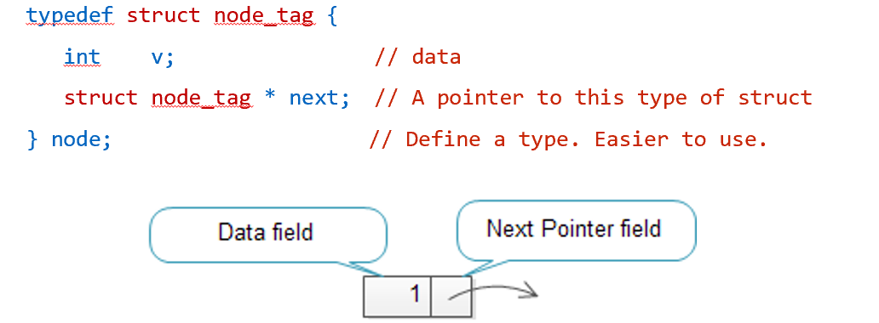

Head

Node * head; // head is a pointer not a node

Head = NULL; // at beginning it is empty